**NHS App medication ordering**

We are getting an increasing number of people contacting the surgery requesting unnecessary GP appointments because they either cannot order their medication via the NHS app or it is telling them they need a GP review before they can order/order next time.

We have a proactive medication review system at the practice managed by our pharmacy team. Most reviews can be made through a review of your notes and your most recent blood tests. A lot of the time you do not need to physically speak to a GP to get your annual medications reviewed.

**Why can you not order your medications via the NHS App?**

You may not be able to order your prescription items if:

1. You need a medicine review by the practice team.
2. It is too early to order your medicine.
3. It is an acute (short-term) or one-off prescription.
4. You have already requested it.
5. You have a repeat dispensing prescription.

**How to check if it is one of the five options:**

1. If you need a medicine review:

The NHS app will tell you that you need to make an appointment with your GP before you order your medications again. This is not necessary at our practice. Other medication apps such as Airmid do not prevent you from ordering when your medications are due for review and allow you to submit your request for medication as a note to us if the app itself will not allow you to select it. It might be worth considering this method of ordering if you are finding the NHS App confusing. Please **DO NOT** ring the surgery to request a GP appointment to discuss your medication review as the NHS App suggests. Instead please send the team a message via the app itself.

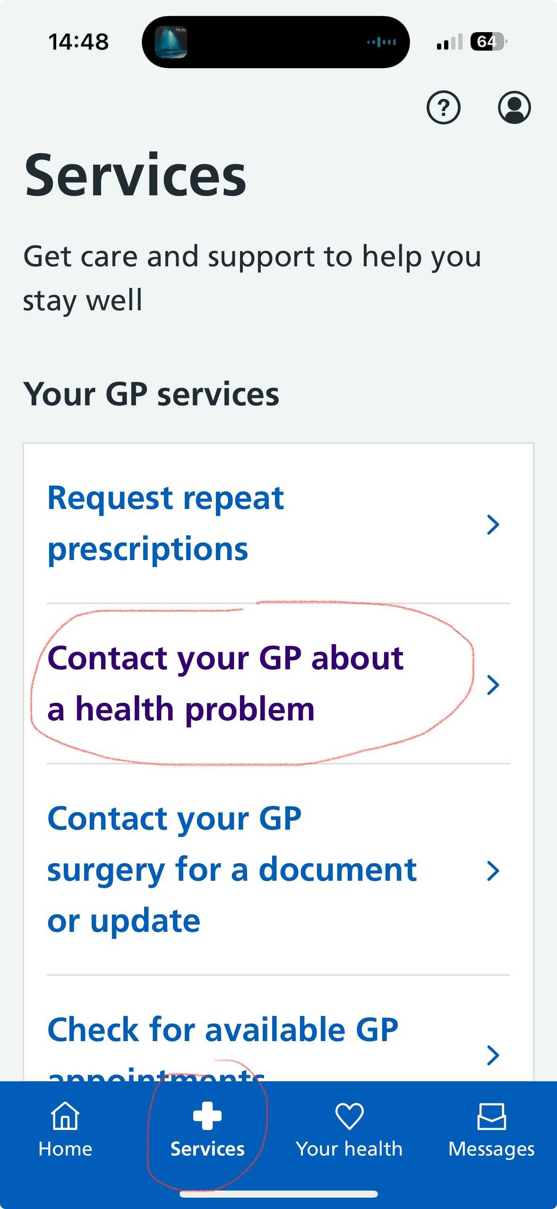

Go to 'services'; 'contact your GP about a health problem'. Follow the prompts and describe briefly what you are trying to order and the message that the app is telling you. Our team will then investigate this for you and be in contact to let you know that it has been reauthorised or with an appropriate action, such as a blood test, pharmacist telephone appointment.

1. If it is too early to order your medicine:

Wait a few days, then check the NHS account again. Our settings mean that you can order your medication 7 days early.

1. If it is an acute (short-term) or one-off prescription:

You cannot order acute or one-off prescriptions using the NHS App. However other

medication apps such as Airmid do allow you to make one off prescription requests.

1. You have already requested it:

If you have already ordered your prescription by phoning your surgery or using another system, such as Patient Access or Airmid. You will not be able to order the same medication across different platforms.

1. You have a repeat dispensing prescription:

You have a repeat dispensing prescription which means your practice will issue your prescription at regular intervals without you manually having to order it. You cannot order repeat dispensing prescriptions using your NHS account.